Baby Massage
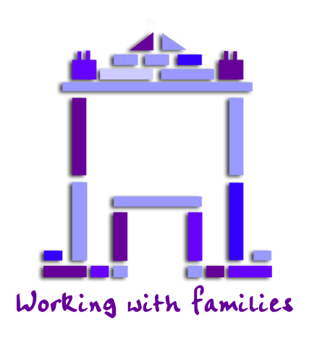
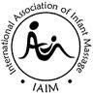
Do you have a baby under 7 months old ?(or not crawling yet)
Would you like to learn how to massage your baby?
Toyhouse has IAIM qualified Instructors and runs courses for parents at:
The Toyhouse Centre, 92 St. Paul’s Way. E3 4AL
The next course will start with session 1 on Tuesday 20th January 1.30 – 2.30pm
following sessions with be Tues 27th January, 3rd &10th February 2026
& will be led by Julie or Afia
(Unfortunately, older children cannot attend the classes)
- 4 x one hour classes run over 4 consecutive weeks
- A full body routine & a short routine to help with colic
- Handouts and time to share experiences
- Group will be small, ideally, we expect you to attend for the full 4 sessions to enable you to cover the full body routine, but we understand this may not be possible. Please speak with us if any of the dates are not possible
- If you would like to attend please complete the application form below and we will get back to you.
- Or for more information please contact:
Julie or Pip on: 020 7987 7399 or email: info@toyhouse.org.uk
..................................................................................
Baby Massage application form (January 26)

Adult details (Please print clearly)
Parent /  Carer Name/s | Ethnicity | Do you give consent to photos being taken YES or NO
Relationship to child(ren) | Language(s) Spoken |  | Interpretation Needed
Address |  |  | Postcode
Telephone | Email (please print)
Where did you hear about the course? | Does your child have any additional needs?
Child details
First Name | Last Name | D.O.B | Gender  M/F | Ethnicity
 |  | / /
 |  | / /
Date _____/____/______

