COOK 4 LIFE

Apply now for our free 4 week fun healthy eating cooking course for you and your child

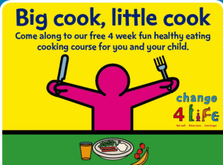
4 WEEK COURSE - BOOKING REQUIRED
AT THE TOYHOUSE CENTRE, 92 St Paul’s Way E3 4AL
020 7987 7399 www.toyhouse.org.uk info@toyhouse.org.uk
- COURSE START DATES: contact us for the details of next course
- EACH COURSE WILL RUN 4 WEEKS FROM THE START DATE

……………………………………………………………………………………………………………………………………………………………………………
COOK 4 LIFE APPLICATION FORM (Please print clearly)
Adult: Name:

Are you a parent / carer of a pre-school child who will also be a course member? YES / NO

Name of your child/ren Date(s) of birth(s):
Contact details: Mobile phone No: Landline:

Postal address:

Post code: Email address (optional)

Do you or your child have any allergies or intolerance to food ________________________________________________________________________________

Where did you hear about the course:

Signed: Dated:
Toyhouse will use the personal information above in order to invite you to Toyhouse services.
Information will be stored securely and not passed to anyone else without your permission

